Appendix C

RAMP-TRIM Users Manual

PC Print Instructions

Formats, Reports and Labels

(Text to be Provided)

United Nations Children’s Fund
3 United Nations Plaza
New York, New York 10017
RAMP-TRIM provides reports for many activities. Reports can be generated for user reference, to manage the transfer process, review inventory and many other business purposes. These reports many be printed or managed electronically, and are generated through the Print Report function.

User Reports User reports are created through the menu option File > Print Report or Ctrl-R key code. All reports are generated from a search result. Accessing this option presents a number of reports that an available to print. These reports are listed on the screen left as shown Figure 1. Print Report (Users).

Adhiratha, What is the report title that should be used by the users?

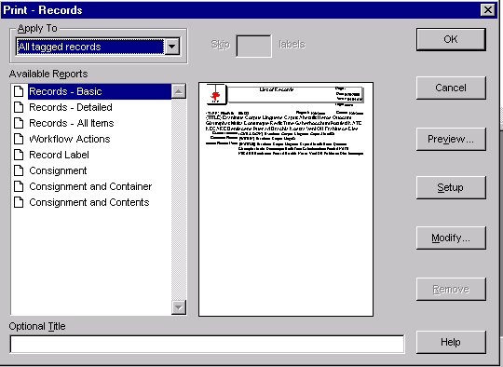
Figure 1. Print Report (Users)

This option also provides a feature to preview the report, change the page layout (Setup), and modify the title. Use the Optional Title feature to add a custom title to the report. As illustrated here in Figure 2. Customize the Report Title. The custom title will appear as shown in Figure 3. Report with Custom Title.

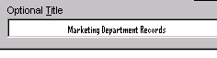
Figure 2. Customize the Report Title


Figure 3. Report with Custom Title

Management Reports Management reports are created through the menu options Process > Report functions. Each report option functions in essentially the same way. First select the type of report required, conduct a search and print the report.

Navigate to this feature. Through this list you can print reports summarizing records requested, contacts, organizations, staff, position, units, thesaurus terms, retention schedules, record plans, security breaches, work indices, workflow statistics, workflow, and scanner controls. These report are shown in Figure 4. List of Management Reports.

Each of the reports can be customized by using the Report Modify Feature. Consult with the RAMP-TRIM Administrator for more information on report modification.
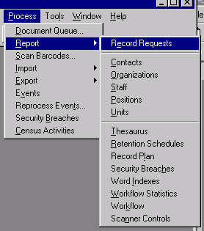
Figure 4. List of Management Reports

